Chemical Formulas

- ___________ are the basic units of ________. Atoms join together _____________ to form molecules.
- Elements are pure ____________.
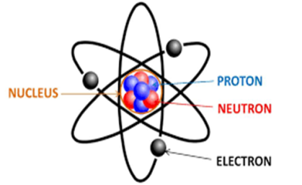
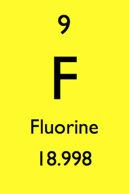
- Elements are represented by 1-2 letters called _________ on the _____________ ____________.

Elements
- Elements are _______ substances made from atoms of that element.
- Examples: ___ and Mg
Molecules
- Molecule is a term used to refer to ____ or ______ atoms which are ________ bonded together.
-Examples: O2 and CO2
Compounds
- Compounds are substances made of ______ or more different elements ____________ combined in a set ratio.
- A chemical ___________, or electric force holds the atoms together in a compound.
- CO2 is both a __________and a __________ as well.
- The properties of a compound are usually __________ from the elements that make up the compound.
-Example
  - Salt is composed of ___________ (Na); a silvery metal; and _______________ (Cl); a stinky green gas
    - When they bond to form _________, they form solid white crystals which you can eat!
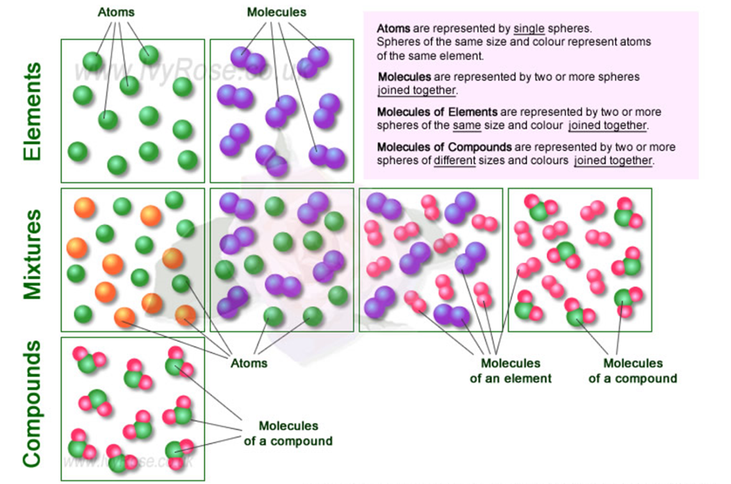
Chemical Formulas
- Symbolic representation of a chemical compound.
- _____________ ____________ are used to identify substances and determine the __________ of atoms of each element.
- The elements present in a compound are identified with the element’s ____________.
- If more than _____ atom of an element is in the compound, it is shown with a ___________.
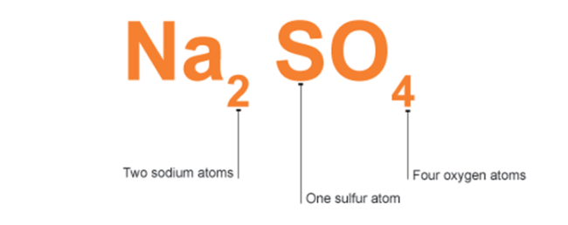
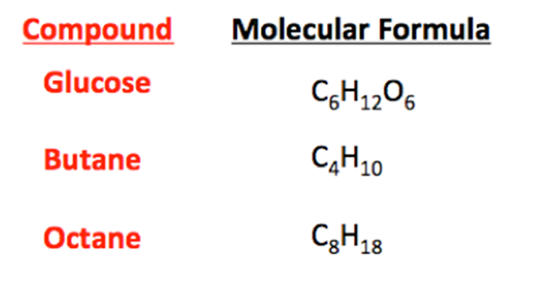

Subscripts
  - Small numbers behind the element or compound
  - Shows the number of atoms in each substance.

- NH₃ Total Atoms:
Different Elements:

- NaCl Total Atoms:
Different Elements:

- H₂O₂ Total Atoms:
Different Elements:

Coefficients
  - Numbers in front of the chemical formula
  - Shows the number of molecules of each Chemical Formula.
Total Atoms:
Different Elements:
Molecules:
Different Elements:

- 2NH₃

Total Atoms:
Different Elements:
Molecules:
Different Elements:

- 3NaCl

- 4H₂O₂
Total Atoms:
Different Elements:
Molecules:
Different Elements:

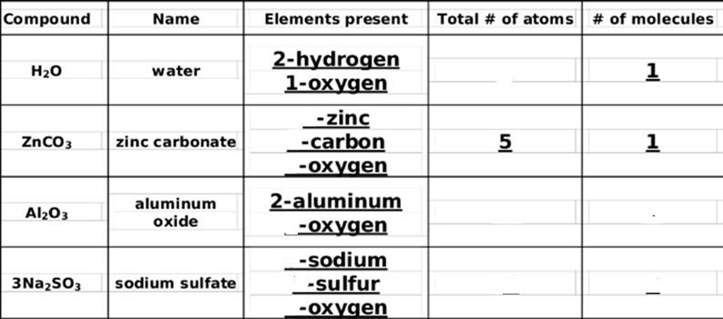Write the number of atoms, elements & molecules for each formula:

- NaOH
Total Atoms:_______
Different Elements:_______
Molecules:________

- MgCl2
Total Atoms:_______
Different Elements:_______
Molecules:________

- 2NaOH
Total Atoms:_______
Different Elements:_______
Molecules:________

- NaC2H3O2
- 3HNO
Total Atoms:_______
Different Elements:_______
Molecules:________

- Li2SO4
Total Atoms:_______
Different Elements:_______
Molecules:________

- 3Al2O3
Total Atoms:_______
Different Elements:_______
Molecules:________

- 4Li2O

Total Atoms:_______
Different Elements:_______
Molecules:________
Total Atoms:_______
Different Elements:_______
Molecules:________

