The purest form of a chemical substance and are composed of only one type of atom.  Element or Compound | A chemical substance that is composed of at least two different types of elements.  Molecule or Compound
A substance that is formed when two or more atoms are chemically bonded together, the atoms can be the same type or different types.  Molecule or Compound | The materials that are present at the beginning of a reaction written on the left-hand side of the yield arrow.  Product or Reactant
Numbers in front of the formulas, indicating the number of molecules of each kind involved in the reaction.  Co-Efficient or Subscript | Numbers to the lower right of chemical symbols in a formula, indicating the specific number of atoms of the element found in the substance.  Co-Efficient or Subscript
Name the 5 Signs of a  Chemical Reaction.  (PECSB) | How many elements are in  Li₂SO_{4?}
How many atoms are in Li₂SO_{4?} | How many Molecules are in 3Al₂O₃?

A chemical substance that is composed of at least two different types of elements.  Molecule or Compound | The purest form of a chemical substance and are composed of only one type of atom.  Element or Compound
The materials that are present at the beginning of a reaction written on the left-hand side of the yield arrow.  Product or Reactant | A substance that is formed when two or more atoms are chemically bonded together, the atoms can be the same type or different types.  Molecule or Compound
Numbers to the lower right of chemical symbols in a formula, indicating the specific number of atoms of the element found in the substance.  Co-Efficient or Subscript | Numbers in front of the formulas, indicating the number of molecules of each kind involved in the reaction.  Co-Efficient or Subscript
How many elements are in  Li₂SO_{4?}  _{3 – elements/Different} | Name the 5 Signs of a Chemical Reaction.  (PECSB)  Precipitate  Energy Change  Color Change  Smell  Bubbles
How many atoms are in 3Al₂O₃?  3 | How many atoms are in Li₂SO_{4?}  7

How many Atoms of Al are in 3Al₂O₃? | How Many Molecules are in the Reactant Side  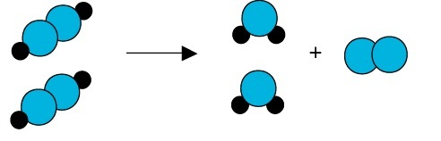
When I say “Atoms” You Say “_______” | When I say “Elements” You say “_____________”
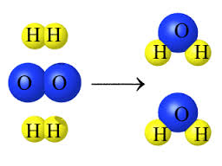  How Many Atom are in the Product Side | 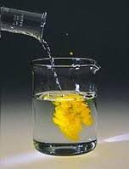
132 g  What is the Total Mass of the Product? | Explain the Meaning of  “What you Start with …. You end With”
Is an Exothermic Change  Hot or Cold | Is an Endothermic Change  Hot or Cold
What sign of a Chemical Change is displayed?

How Many Molecules are in the Reactant Side  1  2 | How many Atoms of Al are in 3Al₂O₃?  6
When I say “Elements” You say “Different” | When I say “Atoms” You Say “Total”
What sign of a Chemical Change is displayed?  Precipitate | How Many Atom are in the Product Side  6
Explain the Meaning of  “What you Start with …. You end With”  The Law of Conservation states Matter can NOT be CREATED nor DESTROYED, Mass just simply moves from one form to the next. | 132 g  132 g  132 g
Is an Endothermic Change  Hot or Cold | Is an Exothermic Change  Hot or Cold

Does the following  Equation Support the Law of Conservation?  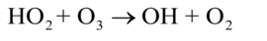 | Does the following equation Support the Law of Conservation?  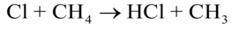
Complete a single T chart for  3C2H4O2  How Many Total Atoms  How Many Different Elements  How Many Molecules | Complete a single T chart for  Na(OH)2  How Many Total Atoms  How Many Different Elements  How Many Molecules
What is the correct chemical formula for a compound that contains 2 atoms of sodium, 1 atom of sulfur, and 4 atoms of oxygen?  A) NA2SO4 B) Na2S1O4  C) Na2SO4 D) na2S1O4 | 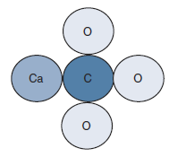  This Molecule represents which of the following?  A) CA2O3C B) CaCO3
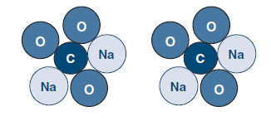  How Many Oxygen Atoms are Present? | How Many Molecules are Present?
Physical or Chemical Change  An ice cube is placed in the sun. Later there is a puddle of water. Later still the puddle is gone. | Physical or Chemical Change  Two chemical are mixed together and a gas is produce.

Does the following equation Support the Law of Conservation?  YES | Does the following equation Support the Law of Conservation?  No – Oxygen is Not Bal
How Many Total Atoms - 5  How Many Different Elements - 3  How Many Molecules 1  Na(OH)2  1  2  2  Na  O  H | How Many Total Atoms - 24  How Many Different Elements - 3  How Many Molecules 3  6  12  6  C  H  O
B) CaCO3 | What is the correct chemical formula for a compound that contains 2 atoms of sodium, 1 atom of sulfur, and 4 atoms of oxygen?  A) NA2SO4 B) Na2S1O4  C) Na2SO4 D) na2S1O4
How Many Molecules are Present? 2 | How Many Oxygen Atoms are Present? 6
Physical or Chemical Change  Two chemical are mixed together and a gas is produce | Physical or Chemical Change  An ice cube is placed in the sun. Later there is a puddle of water. Later still the puddle is gone.

Physical or Chemical Change  A marshmallow is toasted over a campfire. | Physical or Chemical Change  A solid is crushed to a powder.

Physical or Chemical Change  A marshmallow is toasted over a campfire. | Physical or Chemical Change  A solid is crushed  to a powder.

